**Phase 7 : Mini API Integration in Salesforce**

**Step 1: Create Custom Object**

1. In Salesforce, click ⚙️ **Setup** (top right).
2. In **Quick Find**, type **Object Manager** → click **New Custom Object**.
3. Fill:
   * **Label**: Employee API
   * **Plural Label**: Employee APIs
   * **Object Name**: Employee_API
   * **Check**: "Launch New Tab" and "Allow Reports".
   * Save.
4. Add **Custom Fields** inside Employee_API__c:
   * Username__c → Data Type = Text
   * Email__c → Data Type = Email

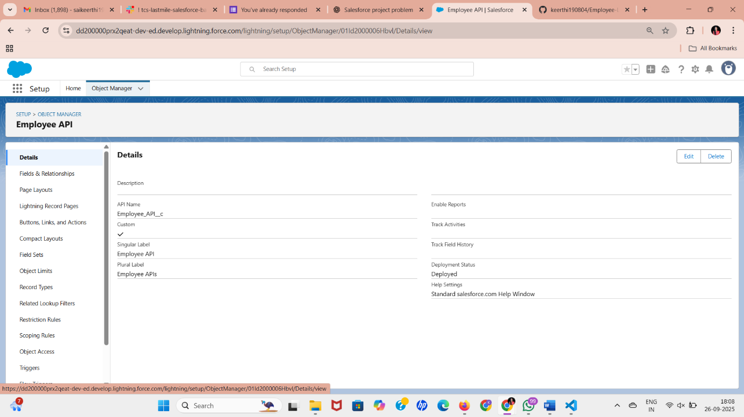

**Step 2: Remote Site Settings**

1. Go to **Setup → Quick Find → Remote Site Settings** → New Remote Site.
2. Remote Site Name: JSONPlaceholder.
3. Remote Site URL:
4. https://jsonplaceholder.typicode.com
5. Save ✅.

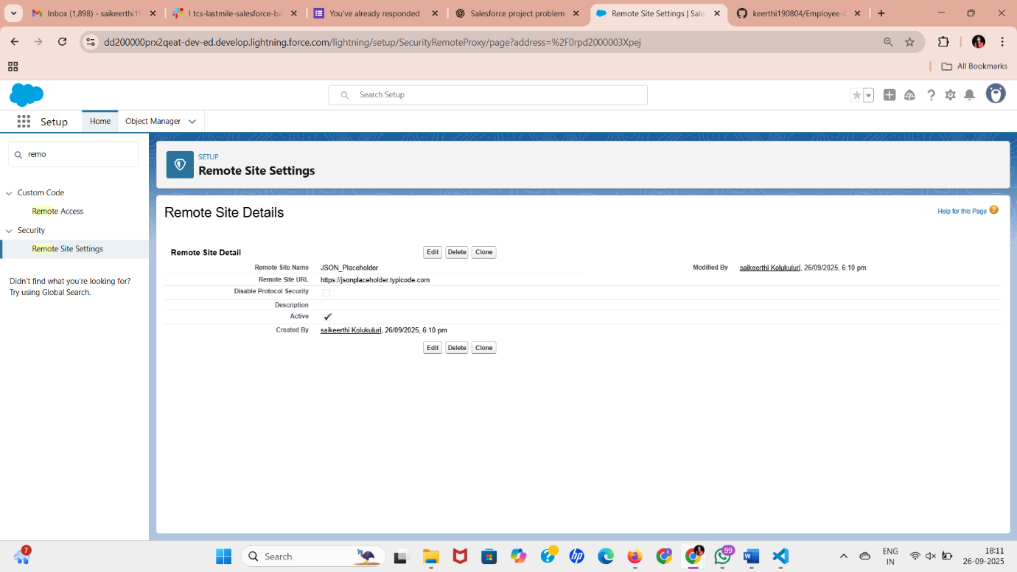

**Step 3: Create Apex Class in Developer Console**

1. Open **Developer Console** → **File → New → Apex Class**.
2. Name: EmployeeApiIntegration.
3. Paste this code:

public with sharing class EmployeeApiIntegration {

@future(callout=true) // Async callout

public static void fetchEmployee() {

Http http = new Http();

HttpRequest req = new HttpRequest();

req.setEndpoint('https://jsonplaceholder.typicode.com/users/1');

req.setMethod('GET');

HttpResponse res = http.send(req);

if(res.getStatusCode() == 200) {

// Parse JSON response

Map<String, Object> results = (Map<String, Object>) JSON.deserializeUntyped(res.getBody());

Employee_API__c emp = new Employee_API__c();

emp.Name = (String) results.get('name');

emp.Username__c = (String) results.get('username');

emp.Email__c = (String) results.get('email');

insert emp;

System.debug('✅ Employee inserted: ' + emp.Name);

} else {

System.debug('❌ API Error: ' + res.getStatusCode());

}

}

}

1. Save ✅.

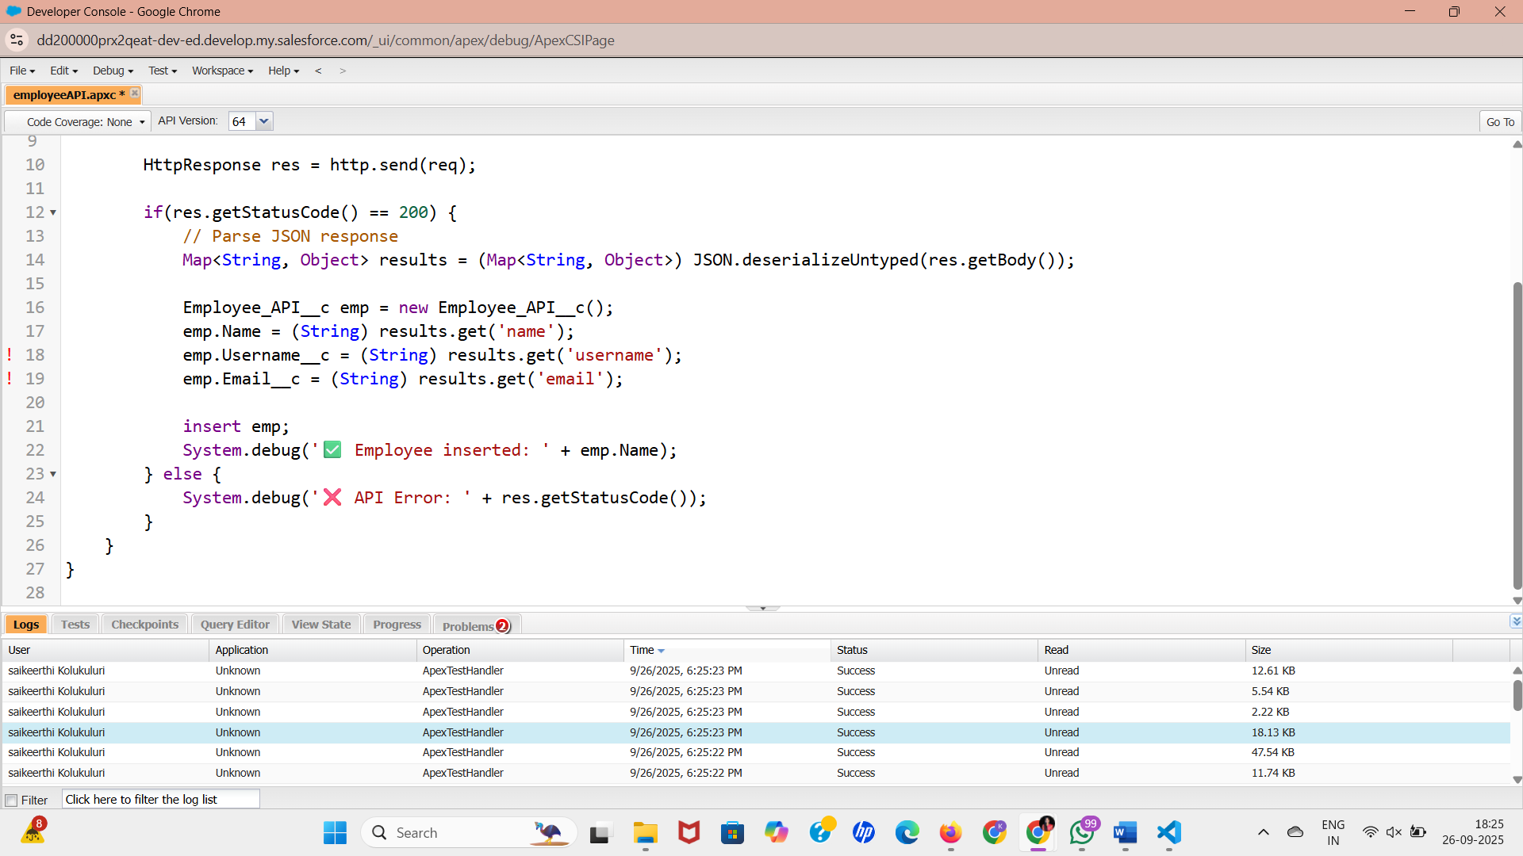

**Step 4: Run the Code**

1. In Developer Console, go to **Debug → Open Execute Anonymous Window**.
2. Paste:

EmployeeApiIntegration.fetchEmployee();

1. Check **“Open Log”** → Execute.
2. Go to **App Launcher (9 dots) → Search “Employee API”** → You’ll see a new record with Name, Username, and Email from the external API

